**Externality Costs Associated with Greenhouse Emissions and Policies to Reduce Them**

Kinjal Shah

HSA10 – 5 The Economics of Oil and Energy

April 6, 2015

**1. Background**

“Earth’s climate is changing, bringing disruption and pain. 2015 was the globe’s hottest year on record, exceeding the previous record set the year before”[1] Headlines like these make the issue of climate change very real. The need to aim for a sustainable future has never been more pressing. We hear about it in our everyday lives, talk about it in discussion forums and read about it in newspapers. Yet, do we really do anything about it? The real question is, can we really do anything about it?

Let me first briefly elaborate on the greenhouse effect. There are essentially two types of greenhouse effects – natural and enhanced. Natural greenhouse effect occurs due to the presence of water vapor, carbon dioxide and other greenhouse gases that are naturally in the atmosphere. The natural greenhouse effect is essential for survival as it increases the temperature of the Earth to a level that is desirable to sustain life. However, the enhanced

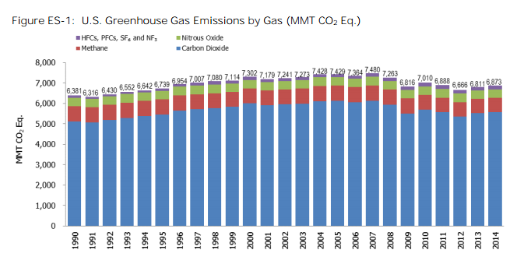greenhouse effect, which is due to human activity, substantially increases the levels of greenhouse gases, raising the temperature of the Earth to higher than what would be desirable. We need to reduce the enhanced greenhouse effect. The main greenhouse gases are methane, carbon dioxide and nitrous oxide. There are other less emitted gases such as sulfur tetra fluoride and NF3. CO2 contributes most to the enhanced greenhouse as is illustrated in Fig. 1 on the left (CO2 is blue on the chart).

*Fig. 1 – U.S Greenhouse Gas Emissions by Gas[2]*

Although the global warming potential (defined as “a measure of how much energy the emissions of one ton of a gas will absorb over a given period of time, relative to the emissions of one ton of carbon dioxide[3]” by EPA) of nitrous oxide is 265 – 298 times that of CO2 and that of methane 28-36[4] times that of CO2, the amount of CO2 released in the atmosphere is much greater than the other greenhouse gases and hence it contributes most toward the enhanced greenhouse effect.

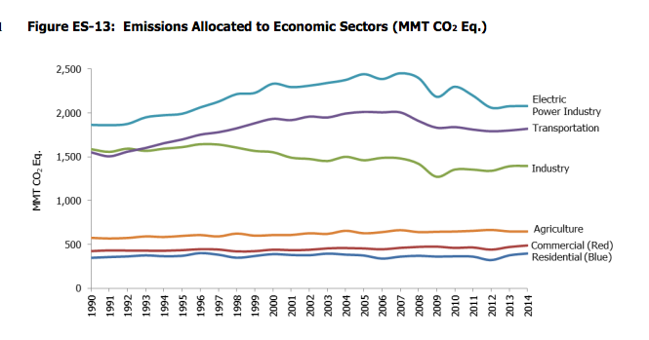Back to the initial question of “Can we really do anything about it?”, let us look at the contributors of CO2. As seen in Fig. 2, the top three contributors of CO2 emissions are the power production, transport and the industrial sectors. Residential is fairly low. Therefore, small efforts on our part to reduce our carbon footprint may have an almost negligible impact on the overall greenhouse emissions. We need to target the industrial sectors to make a significant impact on the overall greenhouse gas emissions.

*Fig. 2 – CO2 emission by sectors in US[5]*

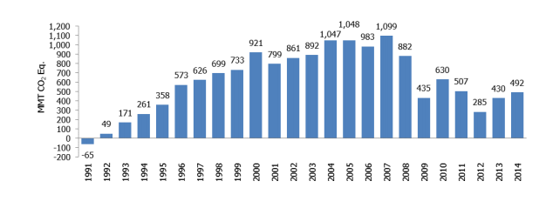Fig. 3 illustrates emissions of greenhouse gases relative to 1990. As can be seen from the plot, greenhouse emissions were at their highest in mid 2000’s, with the rapid growth of the economy and development of the country. However, as the issue of climate change and global warming started becoming a serious issue, greenhouse emissions have

been on the fall.

*Fig. 3 – Annual Greenhouse Emissions relative*

*to 1990 (1990 = 0)[6]*

Unfortunately, the last few years have again seen a rise in greenhouse emissions as the need for power, transport and goods and services has increased. Industries look to minimize their costs in order to survive in a competitive market and the ‘greener’ way is seldom the cheap one. This leads to most industries resorting to ‘unclean’ methods of production, which harms the environment.

**2. Externality Costs Due to Pollution and Market Failure**

When companies fail to take costs to the society as a whole into account, the concept of a market failure is introduced. When any decision is made, there are essentially three costs associated with it. Private costs, external costs and social costs. Private cost, as the name suggests is the cost to the firm/individual of making a decision. External cost is the cost to a third-party that is not involved in the decision-making. Lastly, social cost is the sum of private and external costs. We can now analyze our current scenario and determine the different costs associated with emitting greenhouse gases in the environment. Here, private costs include the costs to the firm of producing the good (machinery, labor, land and so on). External costs include the pollution of natural resources such as air, global warming, acid rain and social cost is the sum of private and external costs. This type of externality is called a negative externality of production because there is a overall negative effect on society due to production methods adopted by industries. The situation of negative externality of production can be summarized in Fig. 4.

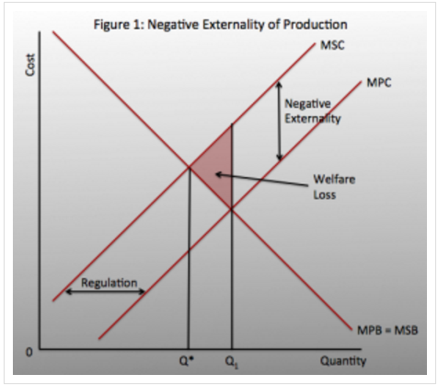A negative externality of production makes the marginal social cost (MSC) greater than the marginal private cost (MPC), due to the presence of external costs. If we look at any given quantity and draw a vertical line up to the MPC and MSC graphs, we can see that MSC is greater than MPC. Market is producing at Q1 however, the optimum amount of emissions should be where MSC = MSB, which is at Q*.

*Fig. 4 – Negative Externality of Production[7]*

We live in a world where resources are scarce and the questions - ‘What to produce?’ ‘How do produce?’ and ‘For whom to produce? have to be answered to allocate resources. In a free market, the quantity where demand meets supply is considered the social optimum. At this point, no one can be better off without someone else being worse off – it is the most allocative efficient situation the market can be in. In this situation, social optimum is at Q*. However, we are producing greenhouse emissions at Q1. Clearly, there is an overproduction, which needs to be reduced.

We therefore see that there is an over-allocation of resources towards production methods that emit greenhouse gases. We need to correct the market failure. This requires government intervention because the free market has failed to allocate resources in the best interests of society.

**3. Government Policies**

Governments have several policies they can implement in order to restrict the amount of emissions by these industries, all of which have positive and negative consequences. Here, we will explore market-based policies such as introducing a cap-and-trade program and imposing carbon taxes and command-and-control policies such as enforcing strict laws and regulations.

**3.1 Cap-and-Trade**

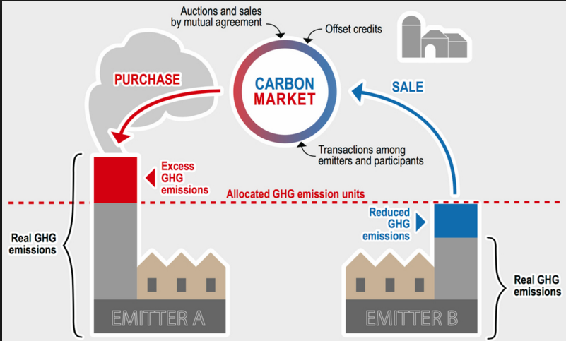The approach here is that the regulators set a maximum cap on the total amount of emissions from all firms enrolled in the program, allowing a specific environmental objective or target to be me met[8]. This cap can be lowered as time progresses to reduce the amount of greenhouse emissions in the atmosphere. Individual firms or companies enrolled in the program have to obtain a pollution permit for each

*Fig. 5 – Illustration of cap-and-trade[9]*

unit of emissions in the atmosphere. To begin with, they are given some number of permits and then if they pollute more than what the initial permit allows them to, they have to buy some from other firms who have extra permits. This stimulates a trading platform as some companies are better at switching to ‘cleaner’ methods than others and they can use this to their advantage by selling their extra permits to ‘unclean’ firms[10]. A demand and a supply for permits is therefore created. The price of the permits depends on the demand for the permits. Demand is likely to be high during an economic boom as production levels would be high and demand is likely to be low during an economic downturn when production is reduced. However, the economic performance of a country is not the sole determinant of the demand for permits.

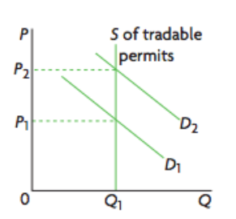

As can be seen in Fig. 6, the supply of permits is fixed and is represented by a singular vertical line. If demand increases (shifts to the left), the price of permits increases and vice versa.

*Fig. 6 – Increase in demand leads to an increase in price[11]*

There are two main ways the initial permits are distributed:

1. Grandfathering

This has been the traditional way of distributing permits. In this case, the regulators release a fixed number of permits to each firm in the program for free and then allow them to trade. This is favored by businesses because they are receiving rights to pollute for free. However, this generates no revenue for the regulators, making the implementation of the program fairly expensive.

1. Auctioning

Many new cap-and-trade programs are adopting this method, at least partly, to distribute initial permits. Here, the regulators hold an auction to sell the initial number of permits and the price is determined again by demand for the permits. This approach opens a pathway to generate revenue, which can be directed towards implementation of the program.

**3.2 Carbon Tax**

Although there have increasing efforts to switch to renewable sources such as solar and wind, there is no major breakthrough in technology that will allow us to completely use clean, renewable sources. They are all seemingly long-term projects because many of them will fail to be competitive enough with our non-renewable sources in use right now such as coal and oil. One of the main reasons this is so is that these energy sources do not take into account the costs to the environment and are therefore severely underpriced. A carbon tax directly tackles this by placing a tax on the CO2 emissions, thereby increasing the price, in the hope that this acts as a price signal and encourages firms to innovate and switch to cleaner methods.

Often, governments impose direct taxes on commodities that release CO2 emissions, increasing the price of the commodity and therefore indirectly increasing the price of carbon. For example, governments can impose fuel tax (gasoline tax) to increase the cost of polluting and releasing CO2 emissions in the environment.

**3.3 Regulations and Laws**

Carbon tax and cap-and-trade have been market-based policies. We can also have a more command-and-control approach where the government imposes laws and regulations to limit CO2 emissions to a certain amount without allowing for any flexibility. For example, it could demand all firms/industries to use a particular technology or adhere to a certain standard.

**4. Which One is Better?**

Let us first compare command-and-control vs. market policies. Taking a command and control approach rather than a market based is likely to be faced with political opposition because industries will be seriously affected by it. This approach offers no flexibility to firms, as it forces them to adopt a method that the government wants them to. This may result in a huge increase in costs of productions as new technology has high initial costs. Moreover, industries may pass on the increase in costs to consumers to maintain their profit margin. This could have a slight probability of contributing towards cost-push inflation primarily if the commodities cover a large percentage of consumer goods. Of course, there are many other factors that will affect the inflation level of an economy but increase in cost of production could be one of the contributors. Lastly, the presence of stringent laws and regulations may shy away foreign direct investments (FDI) into the economy. FDIs generally generate jobs, bring in new technology and help in economic growth and inflexible laws on pollution may not attract them into the economy.

Looking at the two market-based policies, we have cap-and-trade and carbon taxes. The main difference between the two is that in the case of cap-and-trade, the cost of polluting is not fixed. It is determined by the market. This gives firms the flexibility to switch to cleaner production methods if it is more cost-effective for them to do so. Sometimes, it might be cheaper for some firms to continue using the existing production methods and buy pollution permits from other cleaner industries, and they can do that. It is important to keep in mind that the overall emission value is still decreasing because other companies for whom it is cheaper to switch have done so. Therefore, there are lesser overall costs to industries with cap-and-trade because they have two options – to become clean or to buy more permits – and they can choose the one that is best suitable to them.

Apart from being flexible, trading permits also generates revenues for greener firms, thereby encouraging firms to become cleaner. This induces innovation and may direct resources towards research and development of clean technology. Furthermore, if the auctioning method of distributing initial permits is adopted (which is what most regulators use now, at least in part), it can also generate revenues for regulators, which can be used to implement the program effectively. The cost of regulating is usually high and may lead to debts if there is no source of revenue. The same is true for carbon taxes. Carbon taxes increase the cost of production and may therefore encourage firms to innovate and switch to greener technology. However, this depends on the effect a carbon tax has on the firm. If the carbon tax is too low, there is going to be an almost negligible drop in pollution levels, and if the tax is too high, there is going to be discontentment and political opposition (governments have to keep the interests of industries in mind and cannot make the tax too high as it may cause firms to move to other countries and this will be bad for the economy of the country). A suitable standard has to be set, which may be difficult to gauge.

I would argue that while the two market-based policies - cap-and-trade and carbon taxes – can be effective in different situations, the command-and-control approach is likely to be least effective. This is because of the foundation it is based on - lack of flexibility for the industries. This is a highly inefficient way of tackling the issue and is perhaps least effective if we take the interests of all parties involved into account. With the two market-based policies, they both essentially increase the price of carbon. For a long time, carbon has been underpriced, which was leading to overconsumption and so a rise in its price is desirable. They both generate revenues for the government (if auctioning is used) and they both correct a market failure. In the case of cap-and-trade, the reduction in quantity of emissions is certain but the cost of polluting is uncertain. Conversely, in the case of a carbon tax, the cost of polluting is certain and the reduction in the quantity of emissions is uncertain[12]. Therefore, depending on the objective of the countries, one will be more suitable than the other. It does seem that cap-and-trade would be more adopted, as we need to have a guaranteed reduction in emissions given our current global situation. Moreover, the flexibility it offers firms and the trading platform makes it very appealing as a policy. It is likely to be effective at a relatively large scale where there are multiple emitters of greenhouse gases, as that will facilitate trading. At a smaller scale, perhaps carbon tax would probably be more effective[13].

Some countries may even adopt a middle-ground strategy, which combines the concept of a carbon tax and a pollution permit. For example, there could be permits in place but the price of carbon will be monitored and will only be allowed to fluctuate between a price ceiling and a price floor (an upper and a lower bound). This reduces uncertainty associated with cost of polluting while maintaining the benefit of guaranteed reduction in emissions.

I will now introduce two real-world scenarios, which implement the market-based policies explained above. For emissions trading, I will discuss the EU Emissions Trading System and for carbon tax, I will take the example of British Columbia, a province in Canada.

**5. EU Emissions Trading System**

This multi-national emissions trading system is the world’s largest trading emissions program, covering more than “11,000 heavy energy-using installations in power generation and manufacturing industry”[14]. This amounts to more than 45% of the greenhouse emissions in the EU and Fig. 7 highlights the specific greenhouse gases and sectors covered. Generally, all industries operating in these sectors are required to be part of the emissions system. In some of the sectors, firms are only included if they are bigger than a baseline size.

The EU ETS is split into 4 phases as shown in Fig. 8.

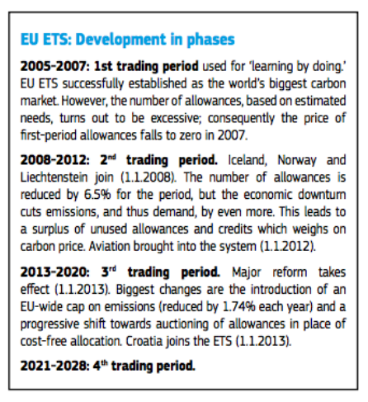

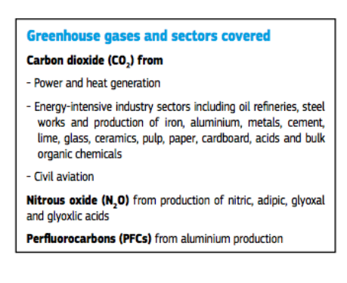

*Fig. 7 – Greenhouse gases and sectors covered*

*by the EU ETS[15]*

*Fig. 8 – The different phases in development of the EU[16]*

When the EU ETS first came into play, all permits were handed out by the grandfathering method. However, since 2013, auctioning has become a larger part of the distribution process. This is primarily because it holds up to the idea that the polluter must pay even for a baseline amount of pollution. Grandfathering allows industries to pollute for free. Regulators have set a target of switching 100% of their distribution method to auctioning by 2027[17].

The EU ETS was not always as successful as it is today. The first two trading periods were a learning guide to further improve the structure of their system. In phase 1, there was an over-allocation of permits by the regulators and this drastically dropped the price of permits to about €0. Data about emissions from phase 1 was used to allocate permits more effectively in phase 2. In phase 2, the EU ETS overachieved its target by 12% but it was unclear if this was due to effectiveness of the trading system or it was simply a consequence of the economic recession in 2008.

Despite the initial failure of the EU ETS system, it strengthened its structure by learning from its failures, as illustrated in Fig. 9. All but two countries had a considerable decline in greenhouse gas emissions between this time period. Some such as France and Romania has almost 40% reduction in emissions.

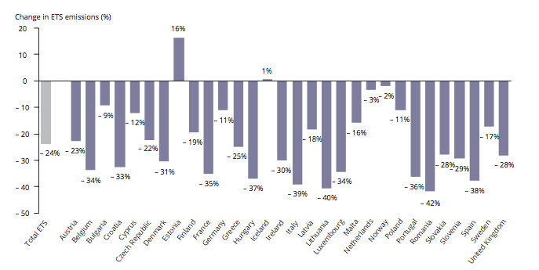

*Fig. 9 – Change in ETS Emissions by Country 2005-2014[18]*

In the long-run, the EU ETS hopes to reduce emissions by 40% by 2030. To achieve this, it plans to reduce number of permits 2.2% per year from 2021. Currently, the rate of reduction of permits is 1.74%[19]. An increase of reduction in allowances by less than 1% annually seems plausible.

The EU ETS was an example of a successful emissions trading program. I will now discuss the case of a carbon tax in British Columbia, which is a successful carbon tax implementation.

**6. Carbon Tax in British Columbia**

The carbon tax in British Columbia was implemented in 2008 and is one of the most significant carbon tax examples in the Western hemisphere. Polluters were charged C$10 per metric tonne of CO2 to begin with and this amount was increased by C$5 every year, bringing the tax to C$40 per tonne today. By 2013, there was approximately a 12.9% decline in the level of carbon-dioxide emissions compared to 2007 (pre-tax).

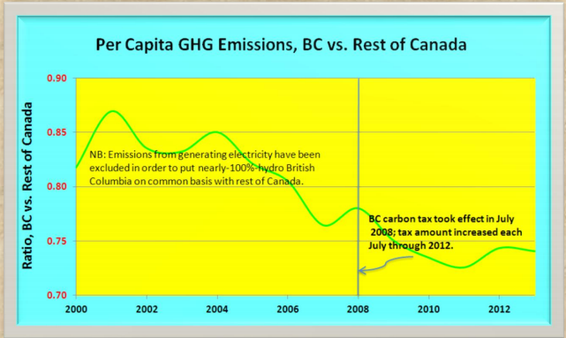

As can be seen from Fig.10, British Columbia has been very successful at reducing emissions. Moreover, the introduction of the carbon tax has not significantly impacted the growth of the economy. The rate of growth of the economy was slower post tax, but the growth was still positive. Therefore, industries have not been strictly against the tax and production has not

*Fig. 10 – GHG emissions British Columbia vs. Rest of* been affected significantly.

*Canada[20]*

One may expect there to be a lot of opposition to the carbon tax, especially if is increasing so steadily every year. However, the main reason behind the acceptance of carbon tax is due to the principle of revenue neutrality. This basically implies that a tax cut in one sector would have an equivalent tax increase elsewhere and vice versa. In the case of a carbon tax, the billions of dollars that is generated as tax are returned to citizens in the form of income and corporate tax reductions. This buffers the impact of the carbon tax, while reducing emissions.

**7. Concluding Remarks**

We explored the different policies a government could implement to reduce greenhouse emissions and to combat the fast-pacing issue of climate change. It was established that market-based policies are, for a large part, better than command-and-control policies. We also saw two very successful examples of both types of market-based policies. This highlights that there is not a singular policy that is better than the other - each policy can be effective in different circumstances. It is just important to correctly identify the situation and decide on a policy accordingly.

Furthermore, when it comes to deciding which policy to choose, it doesn’t necessarily have to be one or the other. There are instances when both can come into play. One such country that follows this is Sweden. Sweden is part of the EU ETS but its government has also implemented carbon tax. This has helped reduce emissions in Sweden and encouraged use of renewable sources of energy. For example, they use bioenergy instead of coal and traditional fuels for heating[21].

Overall, I believe that emissions trading system should be implemented at an international level, as is shown by the EU ETS because the more industries the system covers, the more effective it will be. There will be volatility and trading, which is crucial to the success of a program such as emissions trading. On the other hand, a carbon tax will be very effective on a smaller scale, for example, at a national level or even a local level, as is illustrated by British Columbia. However, the example of Sweden also highlights that implementing both could be equally effective, if not more.

1. (n.d.). Retrieved from http://www.carbontax.org/
2. Draft - Inventory of US Greenhouse Gas Emissions and Sinks (1990-2014). (n.d.), p. ES–4.
3. Understanding Global Warming Potentials . (n.d.). Retrieved from https://www3.epa.gov/climatechange/ghgemissions/gwps.html
4. Understanding Global Warming Potentials . (n.d.). Retrieved from https://www3.epa.gov/climatechange/ghgemissions/gwps.html
5. Draft - Inventory of US Greenhouse Gas Emissions and Sinks (1990-2014). (n.d.), p. ES–23.
6. Draft - Inventory of US Greenhouse Gas Emissions and Sinks (1990-2014). (n.d.), p. ES–5.
7. (n.d.). Retrieved from https://jokhidblog.wordpress.com/2014/01/25/find-an-article-about-a-firm-that-creates-negative-externalities-during-production/
8. How Cap and Trade Works . (n.d.). Retrieved from https://www.edf.org/climate/how-cap-and-trade-works
9. (n.d.). Retrieved from http://www.oilsandsmagazine.com/greenhouse-gas-emissions-carbon-pricing-alberta-cap-and-trade-explained/
10. Carbon tax v cap-and-trade: which is better? (n.d.). Retrieved from http://www.theguardian.com/environment/2013/jan/31/carbon-tax-cap-and-trade
11. Important Diagrams to Remember. (n.d.). Retrieved from http://msfairbairn.weebly.com/uploads/1/3/3/5/13353819/important_diagrams.pdf
12. Carbon tax v cap-and-trade: which is better? (n.d.). Retrieved from http://www.theguardian.com/environment/2013/jan/31/carbon-tax-cap-and-trade
13. Cap and Trade: Essentials. (n.d.). Retrieved from https://www3.epa.gov/captrade/documents/ctessentials.pdf
14. http://ec.europa.eu/clima/publications/docs/factsheet_ets_en.pdf
15. http://ec.europa.eu/clima/publications/docs/factsheet_ets_en.pdf
16. http://ec.europa.eu/clima/publications/docs/factsheet_ets_en.pdf
17. http://climatestrategies.org/wp-content/uploads/2012/02/cs-effectiveness-of-ets.pdf
18. http://www.eea.europa.eu/publications/trends-and-projections-eu-ets-2015
19. http://ec.europa.eu/clima/policies/ets/revision/index_en.htm
20. http://www.carbontax.org/where-carbon-is-taxed/british-columbia/
21. http://www.theguardian.com/environment/2008/apr/29/climatechange.carbonemissions